Train Simulator Student User Manual

# About

This document contains information on how to use the train simulator with your own code. It also goes over some common sources of error and how to address them.

# Setting up your MATLAB Folder:

Follow the instructions for “Getting Started” in the Lab Procedure document for LAB 8A.

Ensure that your current directory is pointing to the folder extracted from the Zip file for the MATLAB Train Simulator and that your script files are also in that folder. The extracted folder should contain a number of files including multiple images and m-files.

# Using the Simulator

As with the Train Setup, you should always start off with the following commands with one small change:

**delete(timerfindall);**

clear all;

close all;

delete(instrfindall);

clc;

When using the physical train setup you would normally connect to the Arduino with a command similar to: “a=arduino(‘COM3’);”. To use the simulator you must simply replace the line with:

a=arduino**_sim**();

Once the command “a=arduino_sim()” has been run, a figure window should pop up showing a drawing of the Train Setup. Many items will not appear until they are initialized. See “Understanding the Train Simulator” below for more information.

**TRY IT!** - The Simulator can be used in the command window or in script file.

To exit the simulator, click the “X” in the top right corner of the figure window. A message box will pop up asking you to confirm that you want to close the simulator. To close the simulator, click the “Yes” button. If you want to keep the simulator running, click “No” and the simulator will continue running.

# Understanding the Train Simulator:

The Train Simulator supports all of the functions that would normally be called on the Arduino and the physical train set. Just remember to include the “**a.**” prefix to any commands.

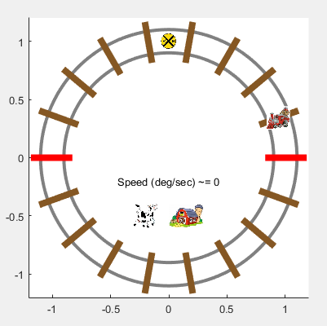

Figure 1 – An uninitialized Train Simulator

## LED’s

* LED’s don’t appear on the screen until they have been set to ‘output’ mode using the “pinMode” command. The digital pin numbers are the same as they are for the physical train setup. This includes the LED’s above the Break Beam sensors, part of an optional challenge presented during Lab 8B.
* Once an LED’s mode has been assigned, they can be turned on and off using the “digitalWrite” command.

## Crossing Gate Servo

* The gate will not appear on the screen until it has been attached using the “attachServo” command.
* The gate only shows two positions: Up & Down. It can be set by using the “servoWrite” command. The gate is down for any angle larger than 100 and the gate is up for any number smaller than 100.

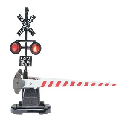 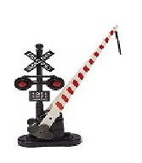

Figure 2. Gate Down (Angles > 100) Figure 3. Gate Up (Angles < 100)

**TRY IT!** – Attach the servo and lower the gate!

## Break Beam Sensors

* The Break Beam Sensors are illustrated on the Simulator as two red lines. The Approach sensor is on the right hand side of the simulator. The Departure sensor is on the left hand side. These can be seen in Figure 1.
* These sensors can be accessed using the command “analogRead”. The analog port numbers are the same as they are for the physical train setup.
* The simulators sensors are programmed to act similar to the physical train setup, notably:
  + The sensor values fluctuate near their appropriate values for unobstructed or obstructed readings. Note these values, especially the unobstructed, might be reasonably off from some of the physical model. You may or may not have to adjust accordingly.
  + The sensors may not return the proper value on the first few calls to “analogRead”. Multiple reads are required until an accurate value will be returned.

## Locomotive Motor

* The locomotive will appear on the screen as soon as the simulator starts. However, until the motor has been set to run forwards using the “motorRun” command, the train will not move (even if you use the “motorSpeed” command).
* The speed of the locomotive can be set using the “motorSpeed” command with input values of 0 – 255.

**TRY IT!** – Run the simulated train at different speed values between 170 – 255. Note how the Break Beam sensors turn green as the train passes over them.

**IMPORTANT:** The speed of the locomotive in the simulator is not a direct representation to that of the physical train set. Due to the performance limitations of many students computers the simulator has purposefully been reduced roughly 70% from the speed of the physical train setup.

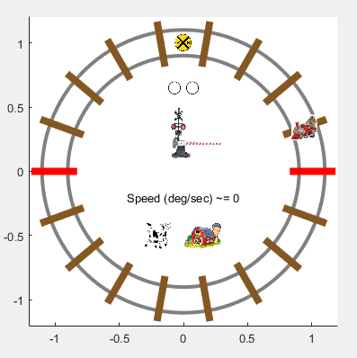

Figure 4 – An initialized Train Simulator

*Note that this figure does not have the optional LED’s above the Break Beam sensors initialized.*

# Some Important Notes:

* If the simulator seems to be working incorrectly, make sure that you ran the following code before starting the Simulator.

delete(timerfindall);

clear all;

close all;

delete(instrfindall);

clc;

Also make sure that you didn’t try to stop the simulator with “CTRL+C” as this will not stop the simulator.

* The simulator does not generate many error codes. If a light isn’t turning on or an image isn’t appearing, make sure that everything is initialized. See Tasks 2-5 in Lab 8A’s procedure for help.
* When switching between the physical train setup and the simulator, it is okay to leave the “delete(timerfindall);” command in your scripts. You just have to simply switch from “a=arduino_sim()” back to “a=arduino(‘COM#’)”. *Hint: You can even create a simple user prompt at the beginning of your program where they select “1” for the physical train setup and “2” for simulator.*